

***School of Mechanical & Manufacturing Engineering (SMME),***

***National University of Science and Technology (NUST),***

***Sector H-12, Islamabad***

Program: BE-Aerospace Section: AE-01

Session: Fall 2023 Semester: 1st

Course Title: Fundamentals of Programming (CS-109)

***“FOP Lab Assignment”***

***Name: Rana Muhammad Abdullah***

***CMS: 468092***

# **ANSWERS TO THE ASSIGNMENT QUESTIONS**

Q.1) Write a C++ program, take two strings as input from user and check if both strings are equal or not. If they are equal make them unequal by rotating string. e.g., Hello is turned into olleH etc.

Ans.1)

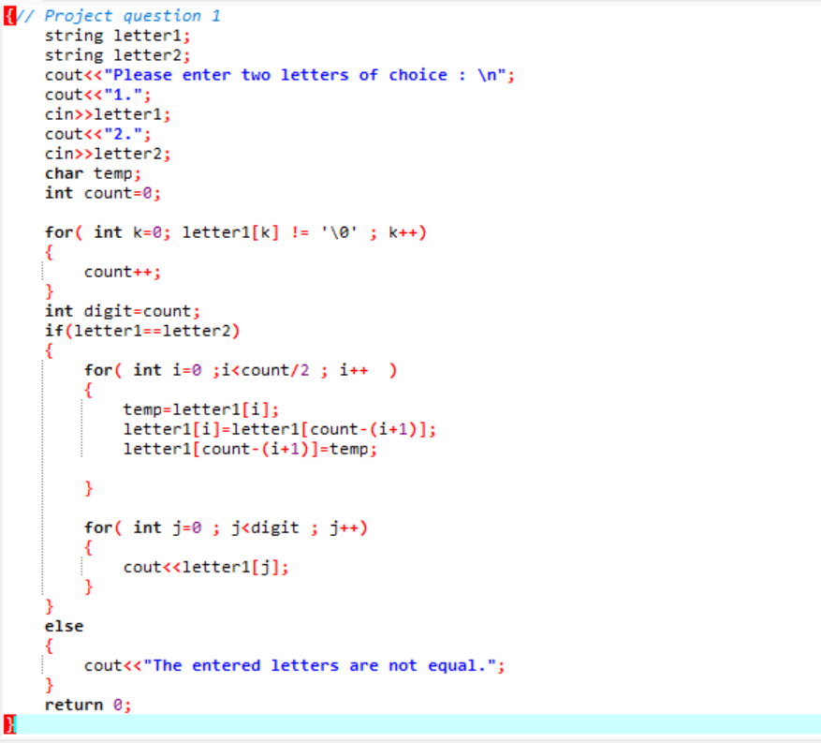**Sample of the above code**

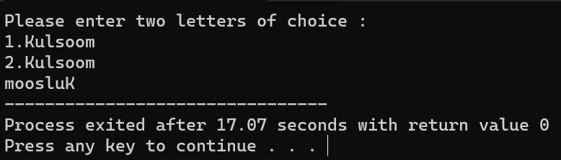

Q.2) Write a C++program for a string which may contain lowercase and uppercase characters. The task is to remove all duplicate characters from the string and find the resultant string.

Ans.1)

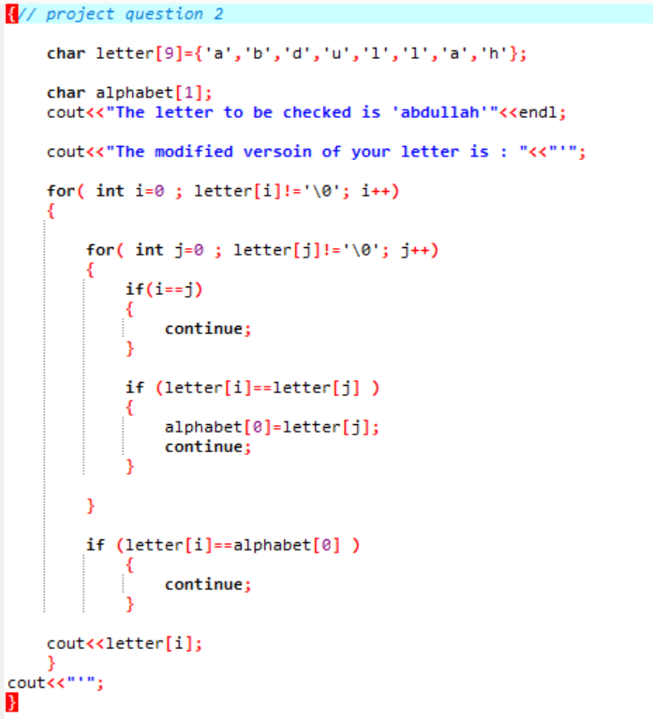

# **Sample of the above code**

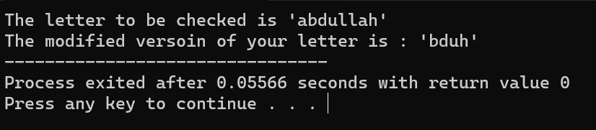

Q.3) Suppose an integer array a[5] = {1,2,3,4,5}. Add more elements to it and display them in C++.

Ans.3)

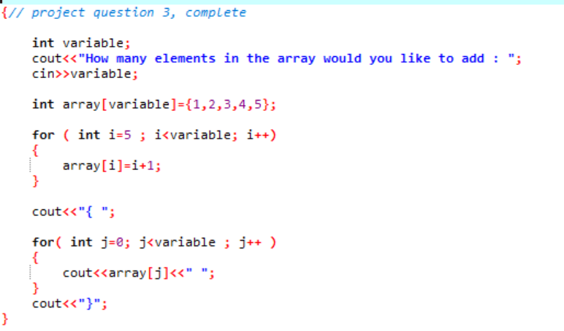

# **Sample of the above code**

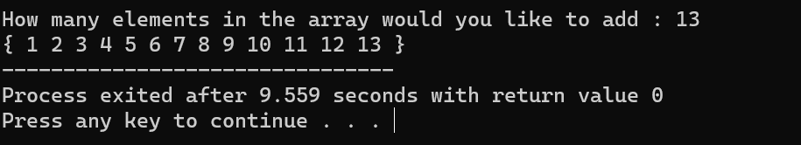

Q.4) Write a C++ program that uses a while loop to find the largest prime number less than a given positive integer N. Your program should take the value of N as input from the user and then find the largest prime number less than or equal to N. You are not allowed to use any library or pre-existing functions to check for prime numbers.

Ans.4)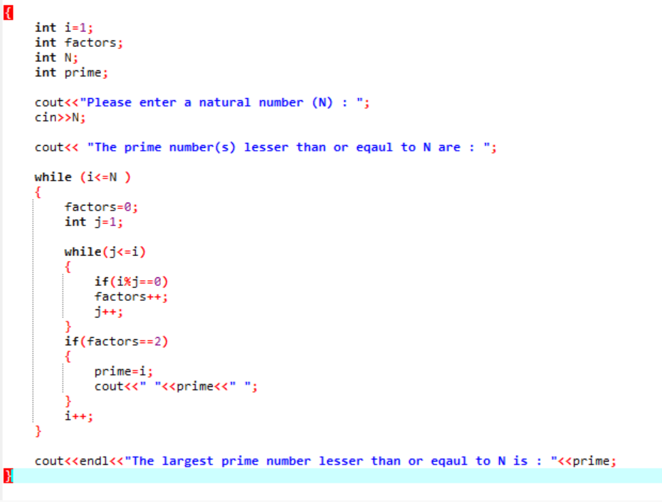

# **Sample of the above code**

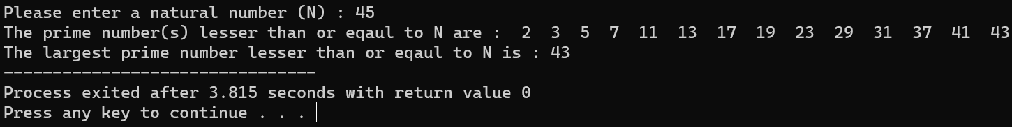

Q.5) Implement Bubble Sort on an array of 6 integers.

Ans.5)

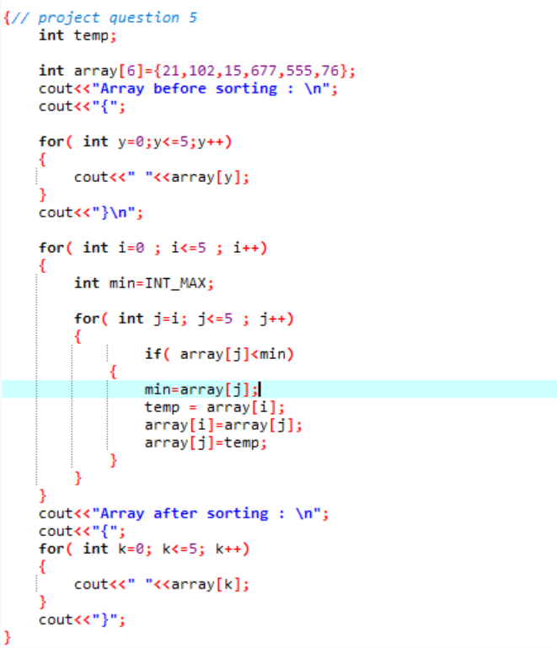

# **Sample of the above code**

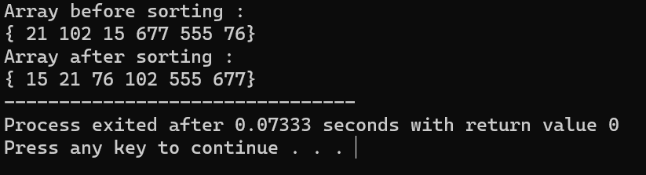

Q.6) . Solve any Aerospace/Real Life Problem using C++ Programming

Ans.6)

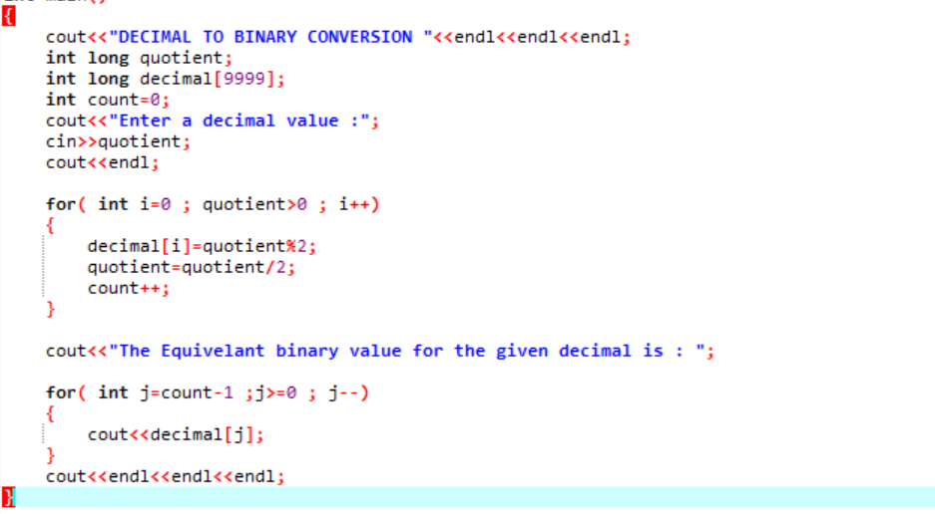

# **Sample of the above code**

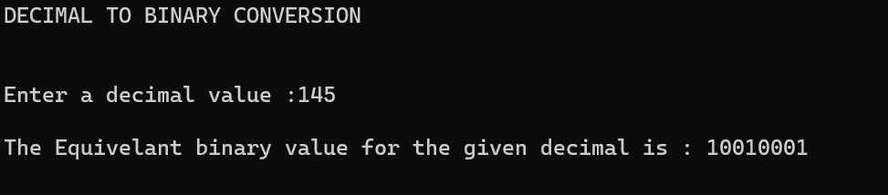

# **The copied code for the above questions**

Q.1)

{// Project question 1

string letter1;

string letter2;

cout<<"Please enter two letters of choice : \n";

cout<<"1.";

cin>>letter1;

cout<<"2.";

cin>>letter2;

char temp;

int count=0;

for( int k=0; letter1[k] != '\0' ; k++)

{

count++;

}

int digit=count;

if(letter1==letter2)

{

for( int i=0 ;i<count/2 ; i++ )

{

temp=letter1[i];

letter1[i]=letter1[count-(i+1)];

letter1[count-(i+1)]=temp;

}

for( int j=0 ; j<digit ; j++)

{

cout<<letter1[j];

}

}

else

{

cout<<"The entered letters are not equal.";

}

return 0;

}

Q.2)

{// project question 2

char letter[9]={'a','b','d','u','l','l','a','h'};

char alphabet[1];

cout<<"The letter to be checked is 'abdullah'"<<endl;

cout<<"The modified versoin of your letter is : "<<"'";

for( int i=0 ; letter[i]!='\0'; i++)

{

for( int j=0 ; letter[j]!='\0'; j++)

{

if(i==j)

{

continue;

}

if (letter[i]==letter[j] )

{

alphabet[0]=letter[j];

continue;

}

}

if (letter[i]==alphabet[0] )

{

continue;

}

cout<<letter[i];

}

cout<<"'";

}

Q.3)

{// project question 3, complete

int variable;

cout<<"How many elements in the array would you like to add : ";

cin>>variable;

int array[variable]={1,2,3,4,5};

for ( int i=5 ; i<variable; i++)

{

array[i]=i+1;

}

cout<<"{ ";

for( int j=0; j<variable ; j++ )

{

cout<<array[j]<<" ";

}

cout<<"}";

}

Q.4)

{// question 4

int i=1;

int factors;

int N;

int prime;

cout<<"Please enter a natural number (N) : ";

cin>>N;

cout<< "The prime number(s) lesser than or eqaul to N are : ";

while (i<=N )

{

factors=0;

int j=1;

while(j<=i)

{

if(i%j==0)

factors++;

j++;

}

if(factors==2)

{

prime=i;

cout<<" "<<prime<<" ";

}

i++;

}

cout<<endl<<"The largest prime number lesser than or eqaul to N is : "<<prime;

}

Q.5)

{// project question 5

int temp;

int array[6]={21,102,15,677,555,76};

cout<<"Array before sorting : \n";

cout<<"{";

for( int y=0;y<=5;y++)

{

cout<<" "<<array[y];

}

cout<<"}\n";

for( int i=0 ; i<=5 ; i++)

{

int min=INT_MAX;

for( int j=i; j<=5 ; j++)

{

if( array[j]<min)

{

min=array[j];

temp = array[i];

array[i]=array[j];

array[j]=temp;

}

}

}

cout<<"Array after sorting : \n";

cout<<"{";

for( int k=0; k<=5; k++)

{

cout<<" "<<array[k];

}

cout<<"}";

}

Q.6)

{ //Question 6

cout<<"DECIMAL TO BINARY CONVERSION "<<endl<<endl<<endl;

int long quotient;

int long decimal[9999];

int count=0;

cout<<"Enter a decimal value :";

cin>>quotient;

cout<<endl;

for( int i=0 ; quotient>0 ; i++)

{

decimal[i]=quotient%2;

quotient=quotient/2;

count++;

}

cout<<"The Equivelant binary value for the given decimal is : ";

for( int j=count-1 ;j>=0 ; j--)

{

cout<<decimal[j];

}

cout<<endl<<endl<<endl;

}